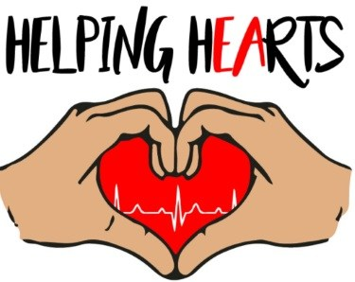

Helping Hearts Charitable Foundation, Inc.

GIFT ACCEPTANCE POLICY AND DISCLOSURE FORM

As part of its Conflict of Interest Policy, Helping Hearts Charitable Foundation, Inc. requires that directors, officers, employees and their family members decline to accept certain gifts, consideration or remuneration from individuals or companies that seek to do business with Helping Hearts Charitable Foundation, Inc. This policy and disclosure form is intended to implement that prohibition on gifts, as some gifts may become more of a hassle than a benefit to the organization such as live animals, real property, motor vehicles, securities, etc.

Section 1. Helping Hearts Charitable Foundation, Inc. solicits and accepts gifts that are consistent with its mission and that support its core programs, as well as special projects.

Section 2. “Family Member” is a spouse, domestic partner, parent, child or spouse of a child, or a brother, sister, or spouse of a brother or sister, of a Foundation staff member.

Section 3. Gifts of real property, personal property, animals or securities may only be accepted upon approval of the Board Members due to the special liabilities they pose to the Foundation.
Section 4. The making of a gift to Helping Hearts Charitable Foundation, Inc. is not a “contract” or “transaction.” “Contract or Transaction” is any agreement or relationship involving the sale or purchase of goods, services or rights of any kind, receipt of a loan or grant, or the establishment of any other pecuniary relationship.

Section 5. Prohibited gifts, gratuities and entertainment. Except as approved by the Chief Executive or his designee or for gifts of a value less than $50 which could not be refused without discourtesy, no Responsible Person or Family Member shall accept gifts, entertainment or other favors from any
person or entity which has received, is receiving, or is seeking to receive a Contract or Transaction with Helping Hearts Charitable Foundation, Inc.

Section 6. Donors and prospective donors may opt out of fundraising mailings via letter or e-mail. A statement providing opt-out instructions is included in all annual campaign correspondence. Helping Hearts Charitable Foundation, Inc., a non-profit corporation, does not sell or share its donor and mailing lists with other companies or organizations.

